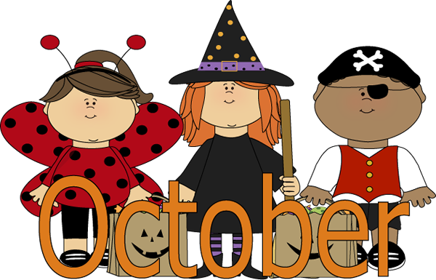 Maysville Schools Lunch Menu
Monday | Tuesday | Wednesday | Thursday | Friday
This Institution Is An Equal Opportunity & Employer. |  |  | Nachos  Veggies  Fruit  Milk | 2  Cheeseburger  Chips  Veggies  Fruit  Milk
5  Chicken Strips  Fries  Veggies  Fruit  Milk | 6  Burritos  Veggies  Fruit  Milk | 7  Pork Roast  Potatoes/Carrots  Hot Roll  Fruit  Milk | 8  Hamburgers  Chips  Tomatoes  Lettuce/Pickles  Fruit  Milk | 9  No  School
12  Chicken Nuggets  Veggies  Fruit  Milk | 13  Taco Soup  Cheese Sticks  Crackers  Fruit  Milk | 14  Hot Dogs  Veggies  Fruit  Milk | 15  Build Your Own Sandwich  Day | 16  Fall Break
19  Fall Break | 20  Mexican Casserole  Veggies  Fruit  Milk | 21  Beans  Cornbread  Green Beans  Fruit  Milk | 22  Grilled Chicken Sandwich  Lettuce  Tomatoes/Pickles  Fruit  Milk | 24  Corn Dogs  Carrot &Celery Sticks w/Ranch  Fruit  Milk
26  Pop Corn Chicken  Fries  Fruit  Milk | 27  Fajitas  Veggies  Fruit  Milk | 28  Pizza Pocket  Veggies  Fruit  Milk  Virtual Day | 29  Little Smokies  Mac & Cheese  Celery Sticks w/ Peanut butter  Fruit  Milk | 30  Hamburgers  Veggies  Fruit  Milk  Cookie

